Name: ___Marundan, Din Earl J.__________________________________________ Section : __BSIT 404_______________

PURCHASING PROCESS

2.

a.

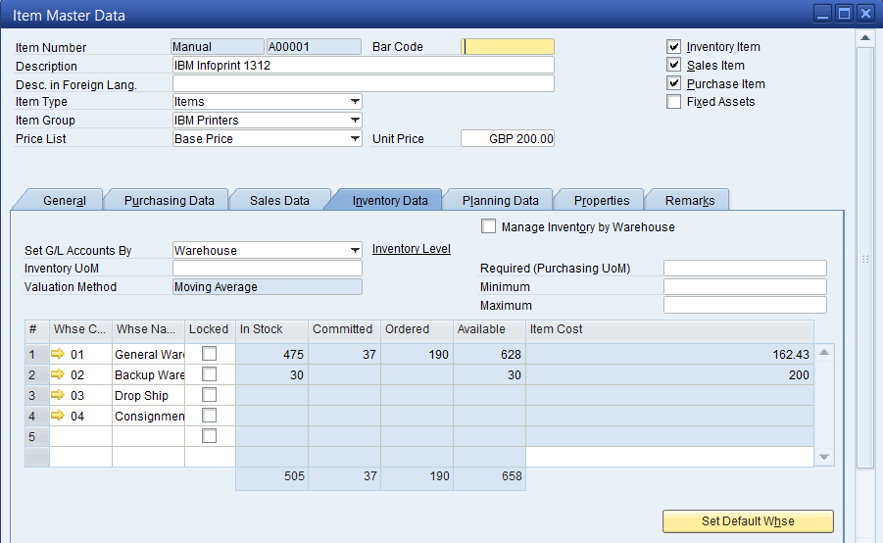

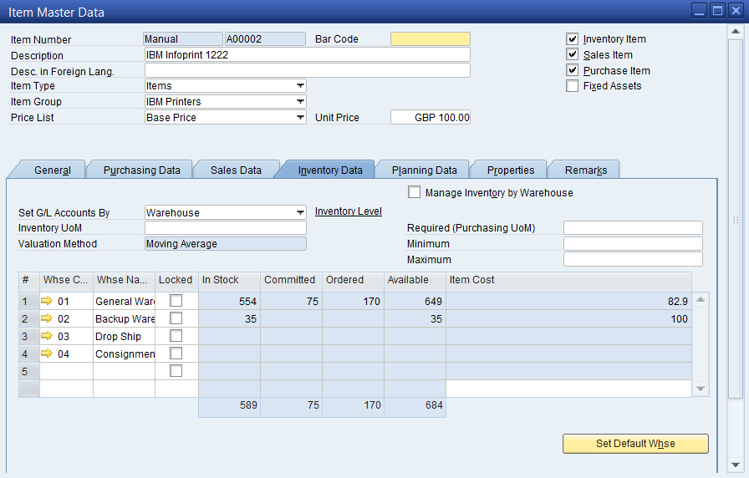

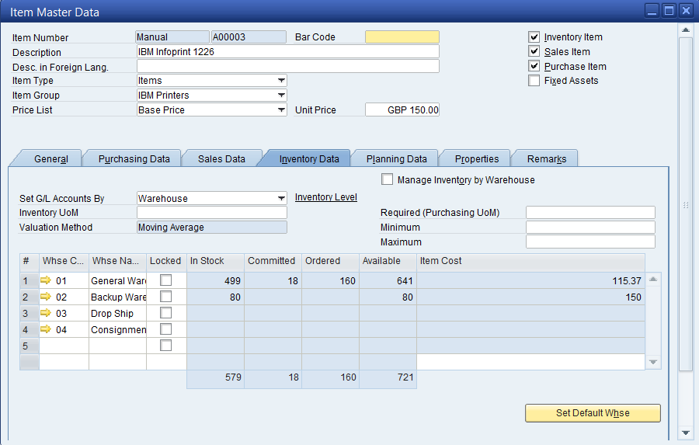

b.

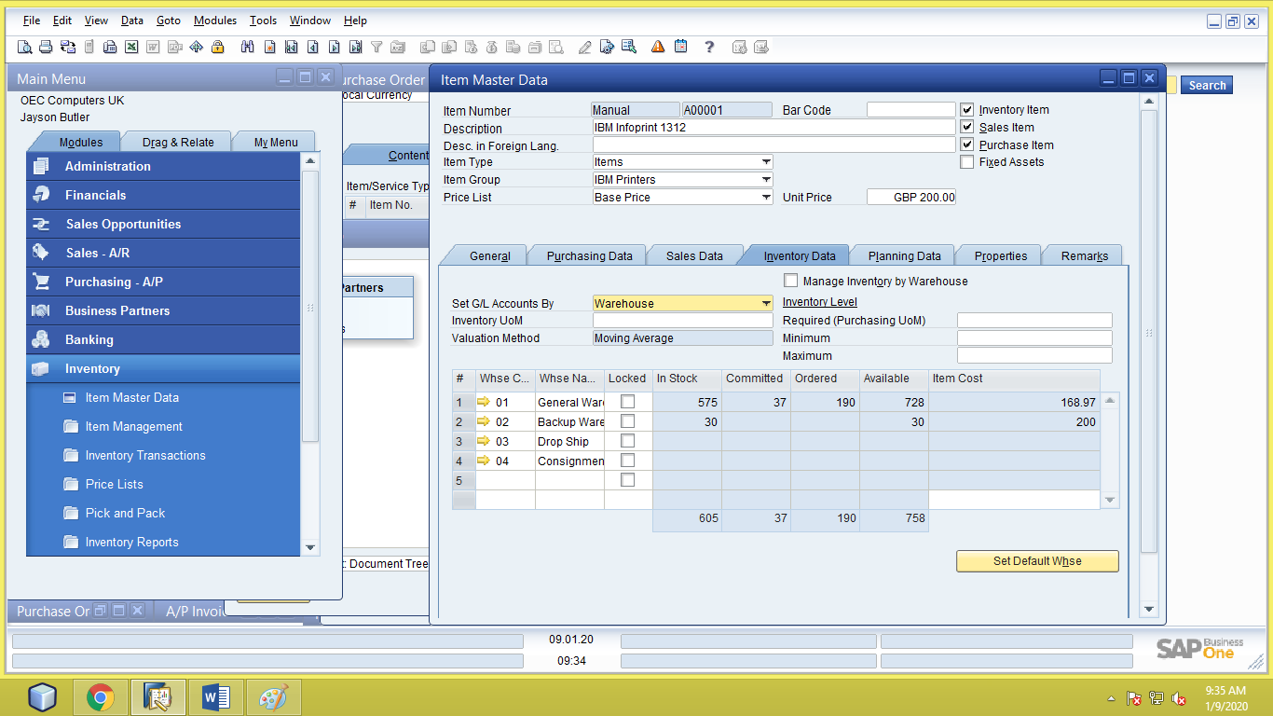

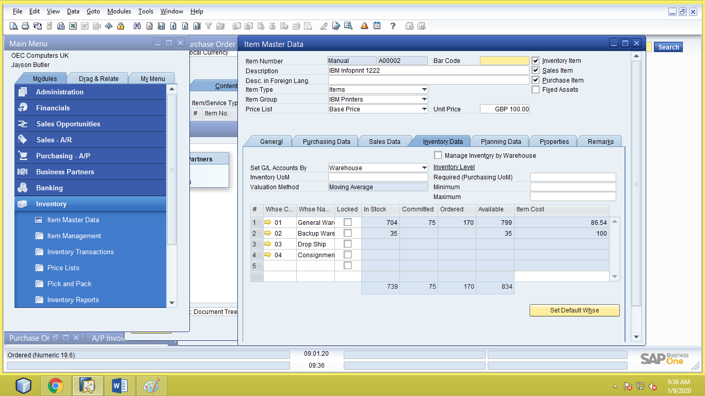

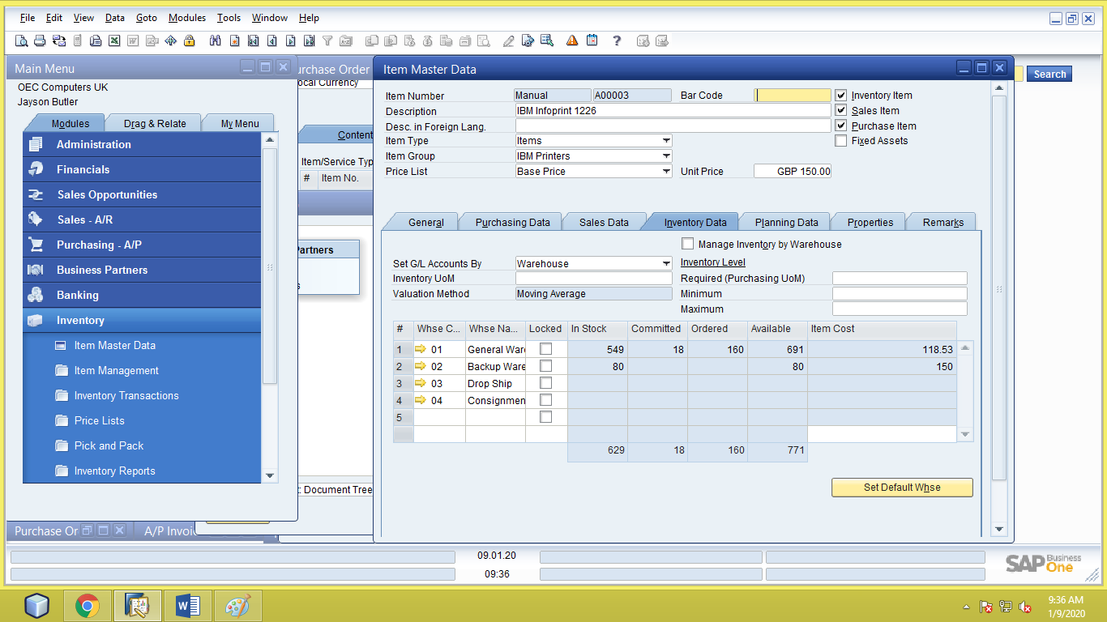

c.

d. OUTPUT:

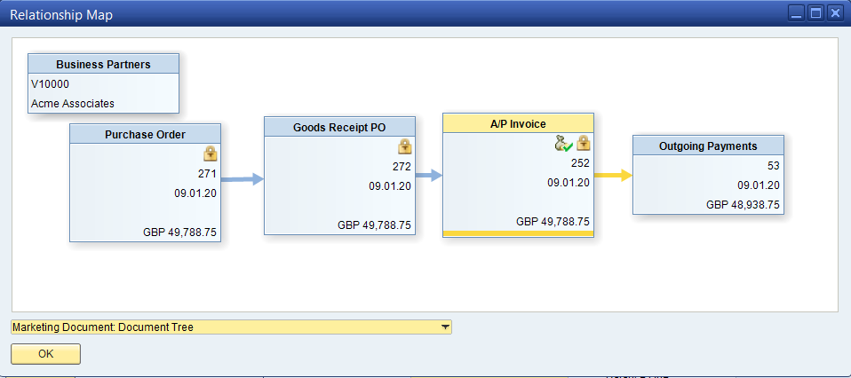

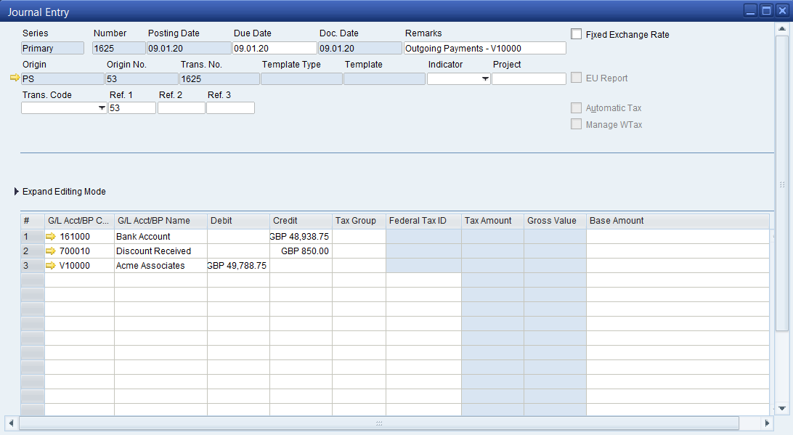

3.

a. 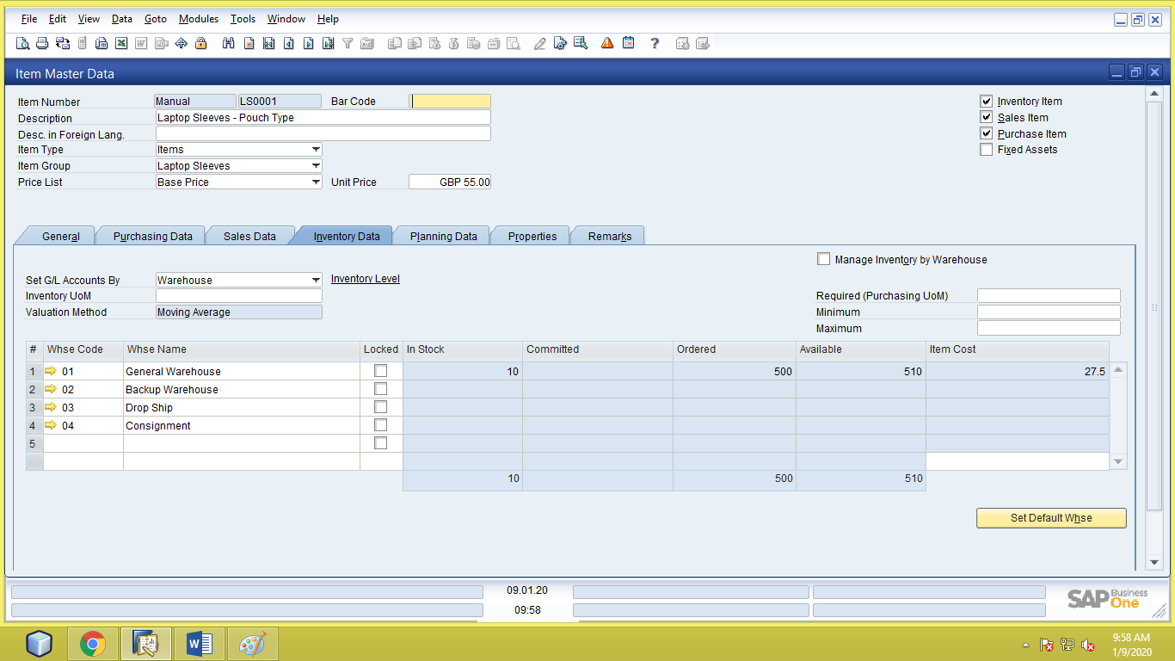

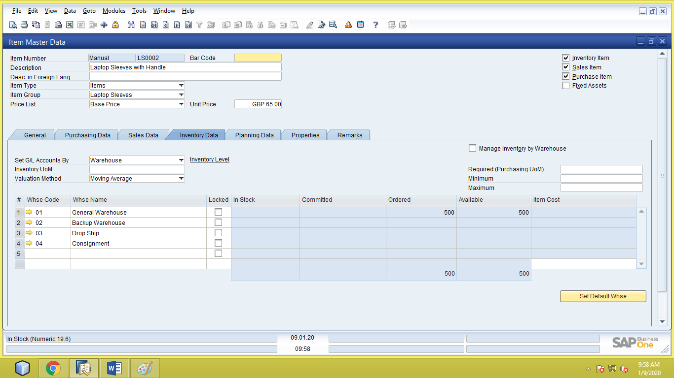

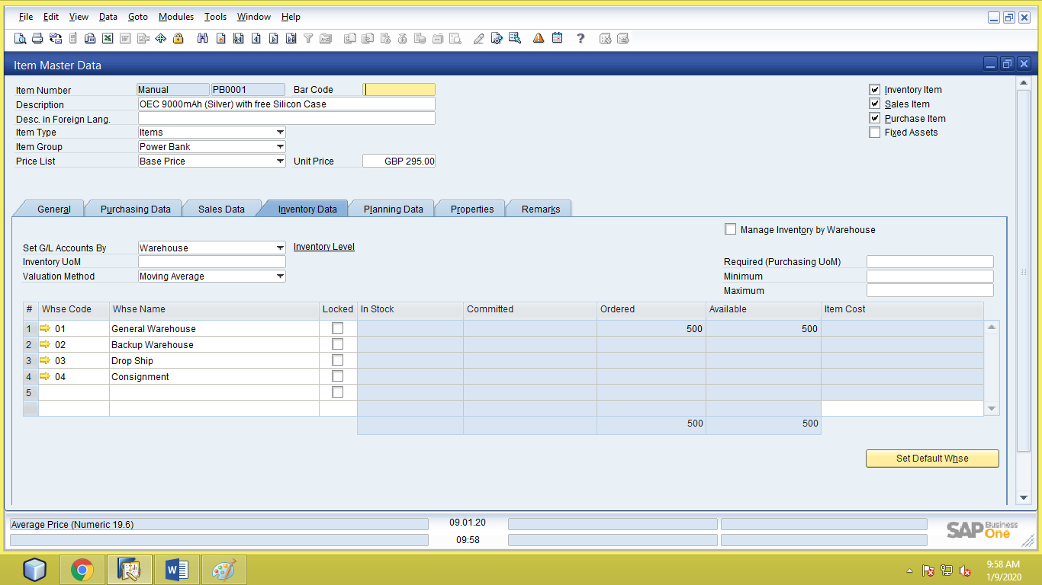

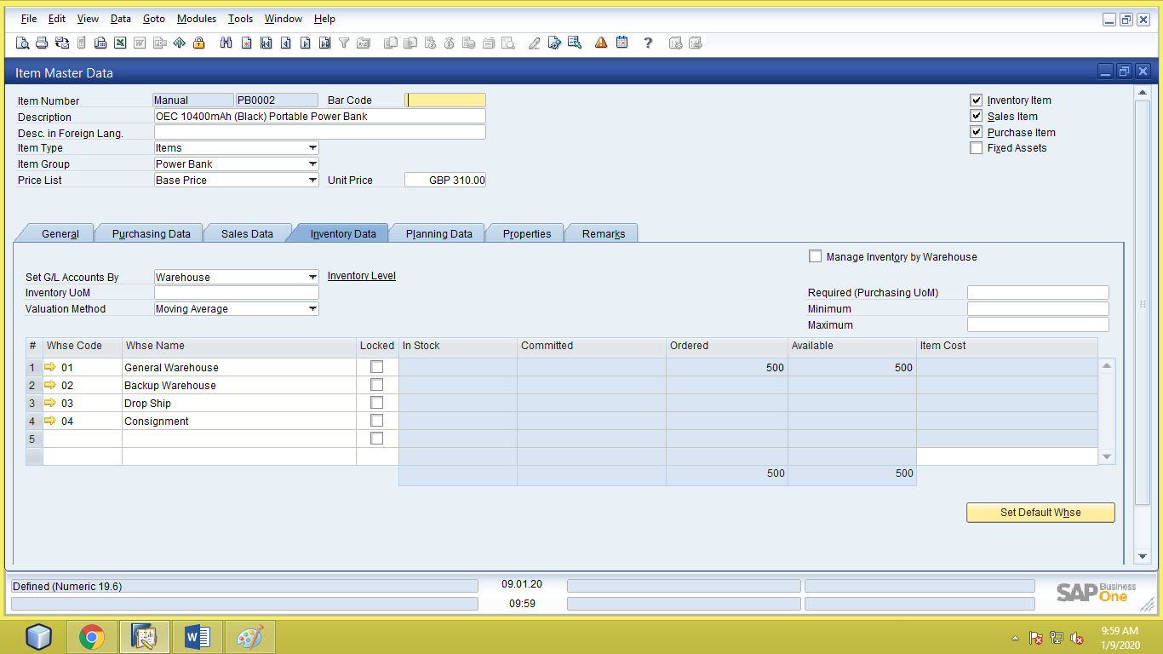

b.